**DAILY ONLINE ACTIVITIES SUMMARY**

|  |  |  |  |  |  |  |  |  |
| --- | --- | --- | --- | --- | --- | --- | --- | --- |
| **Date:** | **13/07/2020** | | | | | **Name:** | **SPOORTI DAROJI** | |
| **Sem & Sec** | **4th SEM. & ‘B’ SEC.** | | | | | **USN:** | **4AL19CS403** | |
| **Online Test Summary** | | | | | | | | |
| **Subject** | | **Microcontroller and Embedded system** | | | | | | |
| **Max. Marks** | | **30** | | **Score** | | | **--** | |
| **Certification Course Summary** | | | | | | | | |
| **Course** | **Programming for Everybody (Getting Started with Python)** | | | | | | | |
| **Certificate Provider** | | | **Coursera** | | **Duration** | | | **7 weeks** |
| **Coding Challenges** | | | | | | | | |
| **Problem Statement :**   1. **Write a Java Program to find the duplicate characters in a string.** | | | | | | | | |
| **Status : Executed** | | | | | | | | |
| **Uploaded the report in Github** | | | | | **Yes** | | | |
| **If yes Repository name** | | | | | <https://github.com/ritikakulkarni> | | | |
| **Uploaded the report in slack** | | | | | **Yes** | | | |

**Online Test Summary: No internals conducted today.**

**Online Certification course Summary:In today's session I gone through some task and I completed coding task.**

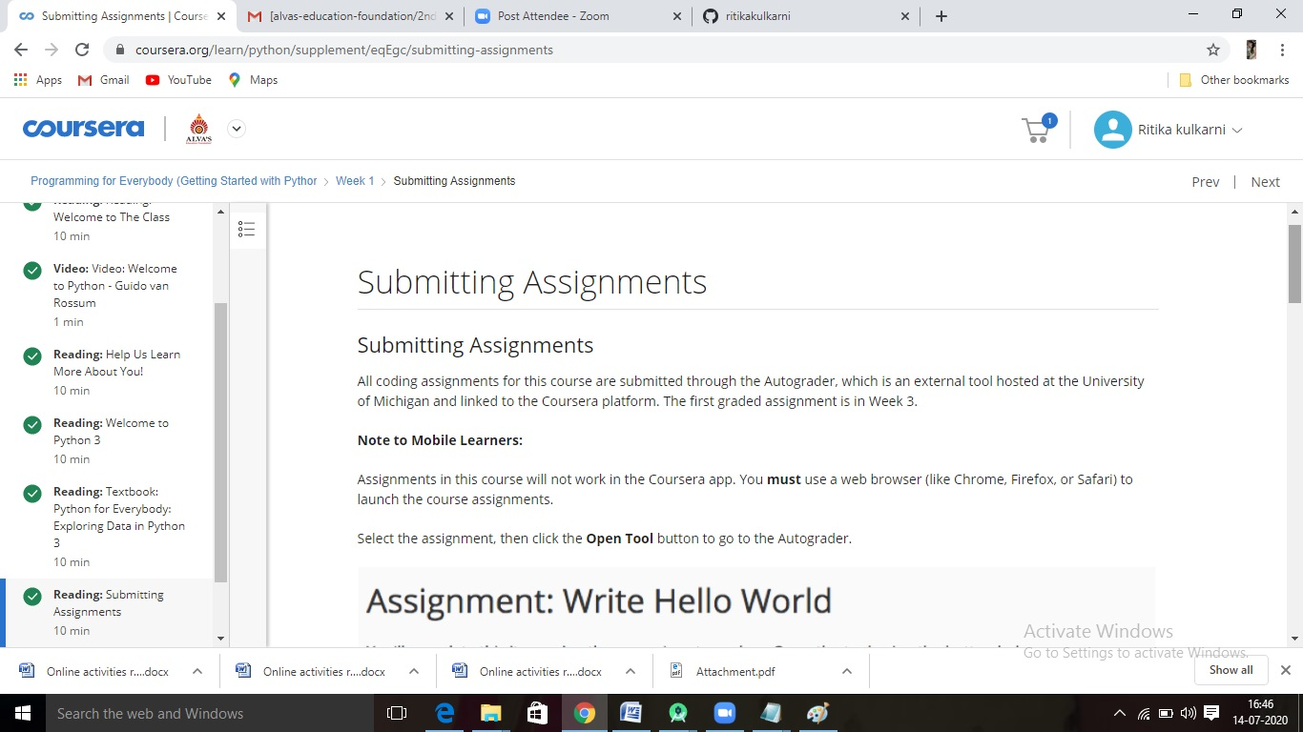

**Online Coding Summary: Today I received the program from prof.Reena lobo CSE Dept.The program is mentioned above in the coding challenges.I have written a program and uploaded it to my Github repository, as shown in the below.**

